Web Design Project – Report

Ellen Woodward

S00222321

23/4/2022

Github Link: <https://ellen-woodward.github.io/WebDesignProject/>

# Initial proposal sketched:

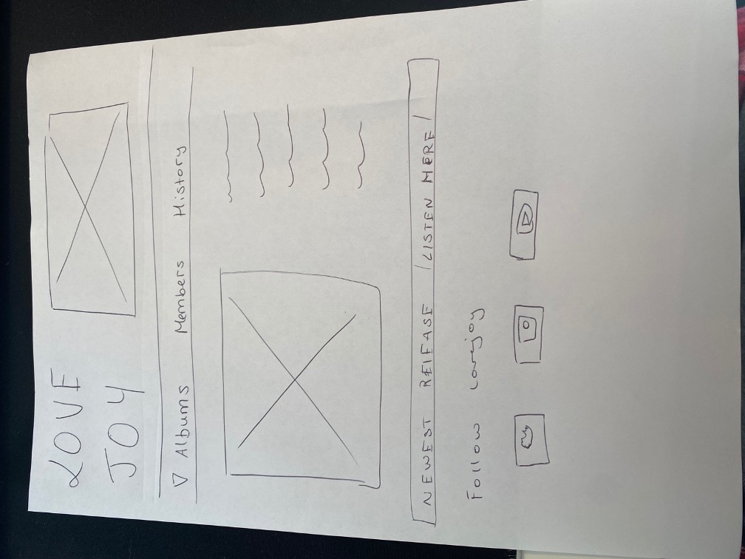

# Checklist

|  |
| --- |
| **R *** GitHub URL Progress upload of web site navigation and 3 pages – Week9** |
| **R Project Report, Upload zipped folders all website files with report, (place college project on front page, no personal information to be included and public domain images and reference text and videos)** |
| **R Minimum of 4 HTML Page Website** |
| **R HTML5 standards and recommended page layout structure** (header,main,aside,article,section,footer) |
| **R Include Meta data – description, keywords, title - Maximise SEO** |
| **R Include font family for body of page** |
| **R Appropriate use of External Style Sheet – Recommended CSS** |
| **R Appropriate Example using Internal Styling on HTML page** (an example) |
| **R Appropriate Example using of inline Styling** (an example) |
| **R Home page content aligned to each other and visually attractive** |
| **R Consistency of design on all pages above fold, aligned, use of fonts, colour etc.** |
| **R Appropriate use of Headings (h1, h2, h3, h4)** |
| **R Appropriate use of Colours, easy to read and complimentary colours** |
| **R Include an article , section and aside sections** |
| **R Clear, consistent and align content on page (reference all sources)** |
| **R Include public domain images (**with at least on image floated with text**)** |
| **R Use of background image** |
| **R Include table of data/information** |
| **R Include lists ordered and unordered (**different shaped bullet points**)** |
| **R Include favicon and logo on your website** |
| **R Include a contact form Display values entered in form and include red * beside required/mandatory input fields** |
| **R Verify data collected on contact form, using get and data attached to URL** (Use the method get to display values entered on form will be appended to url and passed to server<form <action="http://foo.com" method="get">) |
| **R Include google maps** |
| **R Include columns using css that displays 2 or 3 columns on a page** |
| **R Footer information include html entity Copyright© year and footer navigation menu** |
| **R Include Internal Links and External Links** |
| **R All pages should be up to 70% responsive** |
| **R Include suitable video** |
| **R Include Appropriate use of CSS Class and Id selectors** |
| **R Appropriate use content layout using margins, paddings and borders (<br**> only used to split text on separate line eg address) |
| **R Additional Features ___**embedded spotify**_______________** |
| **R W3C HTML & CSS Validator results (in report)** <https://validator.w3.org/nu/#file> |
| **R Report include Proposal, Declaration of your own work , URL to Github, Rough Sketch of layout design, brief descriptions of the web site its pages and sources for information and Validator results** |
| **R Website appearance, design and Content** [**https://webdesignledger.com/10-signs-of-a-user-focused-design/**](https://webdesignledger.com/10-signs-of-a-user-focused-design/)[**https://webdesignledger.com/20-dos-and-donts-of-effective-web-design/**](https://webdesignledger.com/20-dos-and-donts-of-effective-web-design/) |

# Description:

## Home page

Navigation bar at the top, a main section, aside section and a footer. The main section contains a responsive image, two columns of text from <https://lovejoy.fandom.com/wiki/Lovejoy_Wiki>, and an embedded youtube video. The aside section contains pictures of the album covers which are links to the albums’ spotify page. The footer contains a navigation bar and icons that are links to the band’s various social media platforms.

## Album page

Navigation bar at the top, two sections and a footer. The two sections contain an image, text from <https://lovejoy.fandom.com/wiki/Lovejoy_Wiki>, a table with data in it, and an embedded spotify playlist. The footer contains a navigation bar and icons that are links to the band’s various social media platforms.

## Band Members

Navigation bar at the top, four sections and a footer. The four sections, one for each band member, contain an image and text from <https://lovejoy.fandom.com/wiki/Lovejoy_Wiki> which is organised by different styles of lists and bullet points. The footer contains a navigation bar and icons that are links to the band’s various social media platforms.

## Contact Us

Navigation bar at the top, a section and a footer. The section contains a form that asks the user to input their name, email address, gender, where they found out about the website and their query. There is a submit or reset button. There is also an embedded map. The footer contains a navigation bar and icons that are links to the band’s various social media platforms.

# Validator results

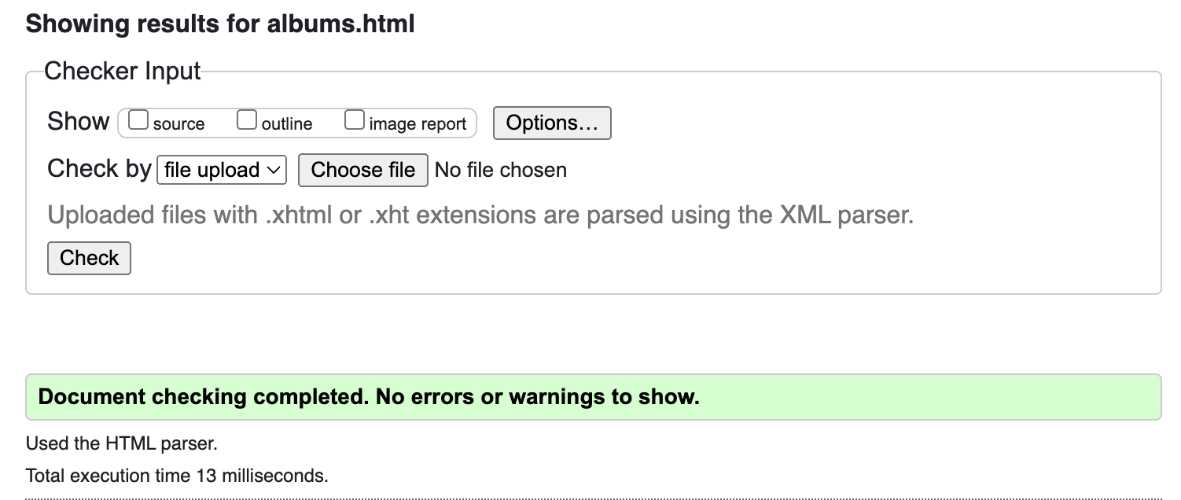

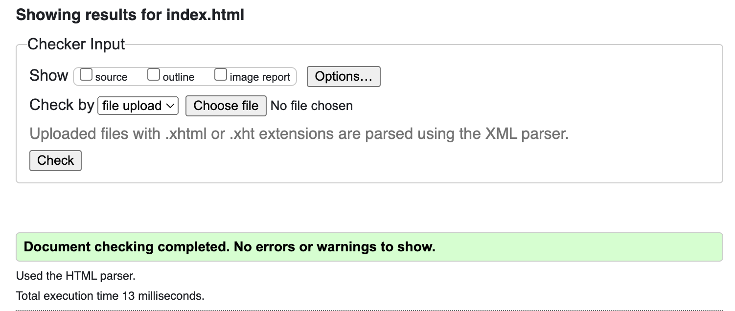

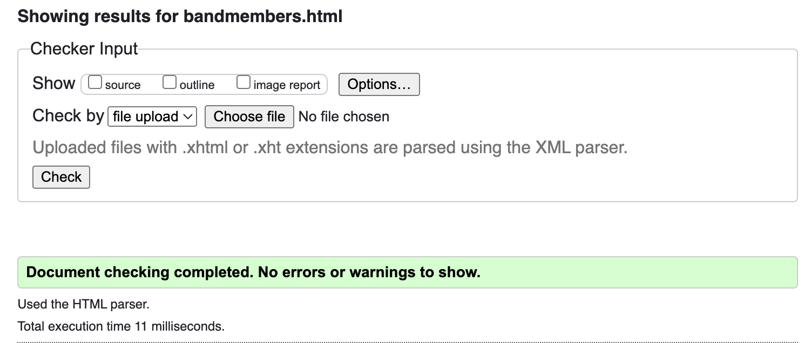

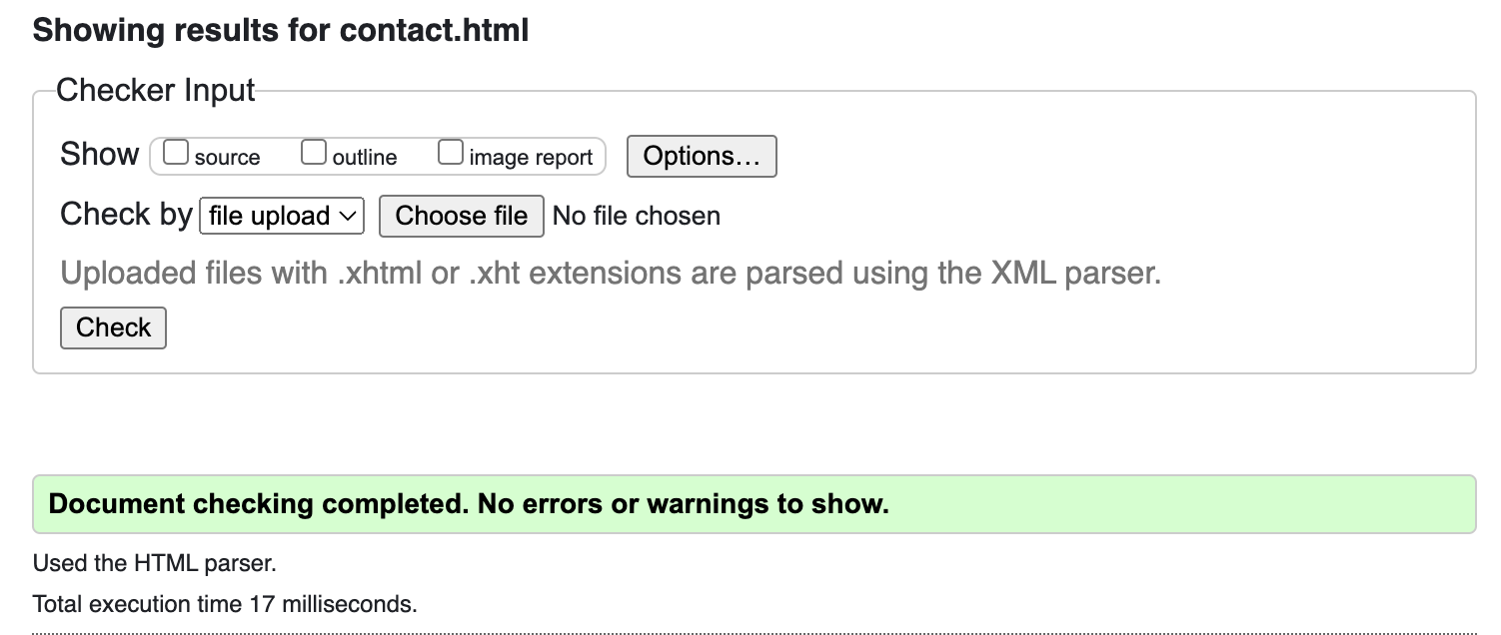

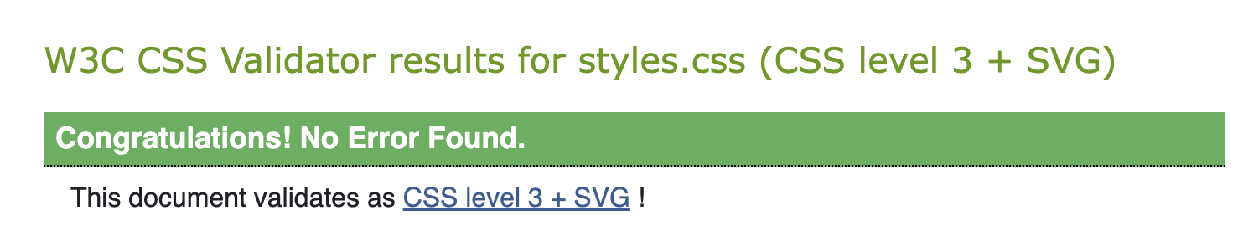

# Declaration

I the undersigned declare that the project material, which I now submit, is my own work. This material or project has not previously been submitted for any other assignment. Any assistance received by way of borrowing from previous work, or the work of others has been cited and acknowledged within the work. I make this declaration in the knowledge that a breach of the rules pertaining to project submission may carry serious consequences. We are aware that the project will not be accepted unless this form has been handed in along with the project.

Website Topic:______________Lovejoy Fanpage_____________________

Student name:______________Ellen Woodward______________________

Student number:______________S00222321_____________________

Date:_______________________23/4/2022____________________